Practical - 4
Practical Title:JavaScript DOM Manipulation, Event Handling, and UI Interactivity

Problem Definition:Add dynamic UI components such as collapsible FAQ, modal popup,
image/content slider, notification banner, hamburger menu, and light/dark theme switcher using JavaScript.

Theory

How are DOM elements selected and modified?
Answer:
DOM elements are selected using JavaScript document methods like querySelector() and modified by updating their properties, styles, or structural methods. This process forms the foundation of dynamic web development

https://www.geeksforgeeks.org/javascript/how-to-select-dom-elements-in-javascript/

Are event listeners attached correctly?
Answer:
Event listeners are correctly attached by selecting specific DOM elements and using the addEventListener() method to bind custom functions to user interactions such as clicks, form submissions, or keystrokes. Proper implementation ensures that user actions seamlessly trigger the desired dynamic behaviors while avoiding issues like memory leaks or redundant event bindings.
https://developer.mozilla.org/en-US/docs/Web/API/EventTarget/addEventListener

3.Is localStorage used for remembering theme choice?
Answer:
Yes ,local storage is widely used by websites to remember user choices and preferences

https://cookie-script.com/blog/local-storage-and-session-storage

4.Does interactivity improve usability without breaking accessibility?
Answer:
Yes, well-designed interactivity improves overall usability without breaking accessibility, provided interactive components are built to support assistive technologies and standard navigation rules.

Implementation/ Output/Result

The StudentHub pages were successfully changing its theme from dark mode to light mode perfectly without facing any problems.

Evidence of Work (Screenshots)

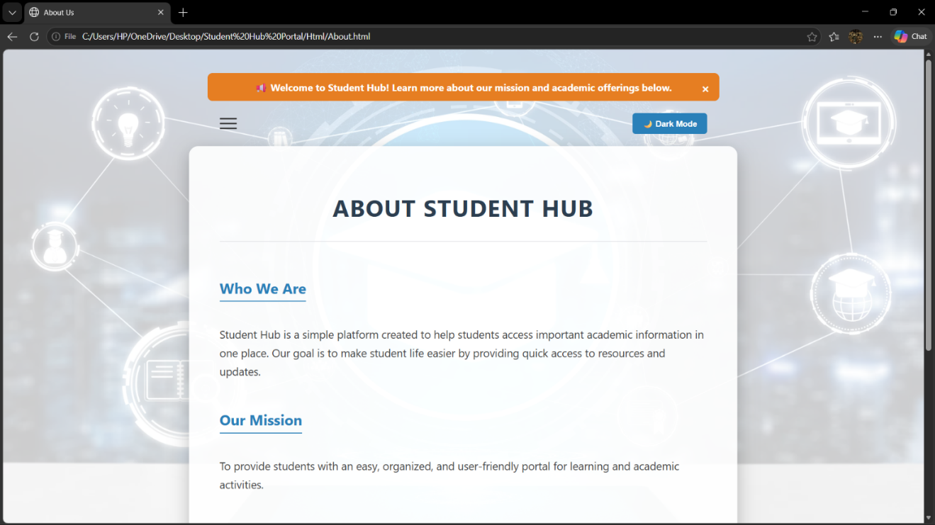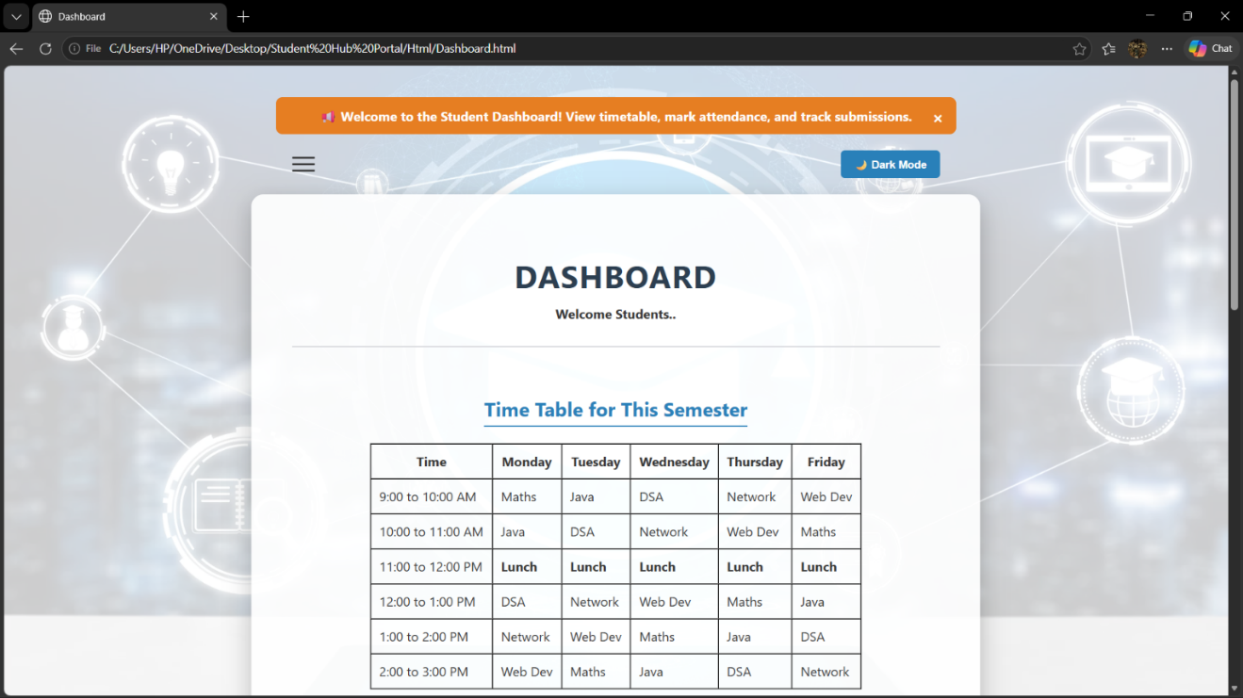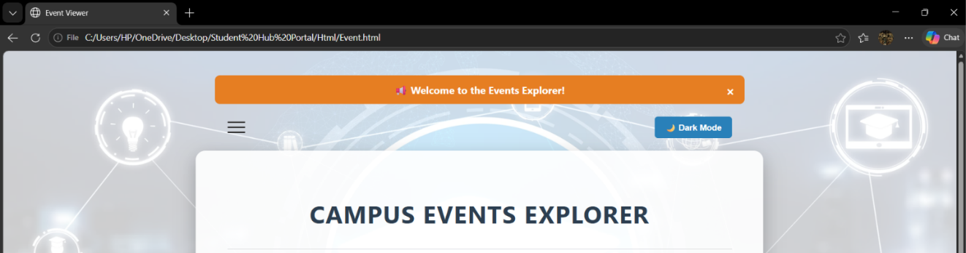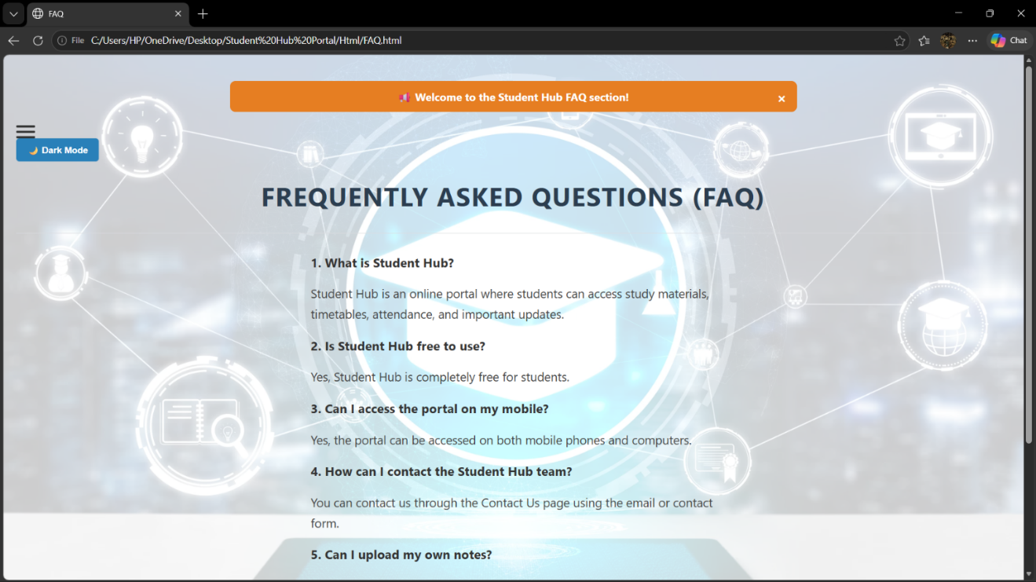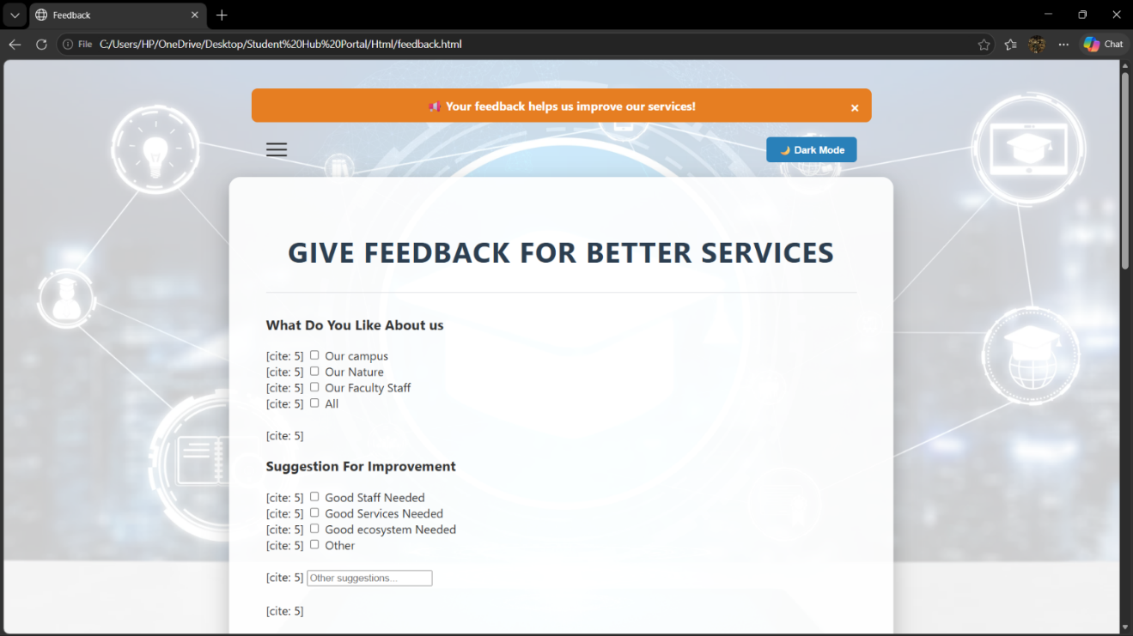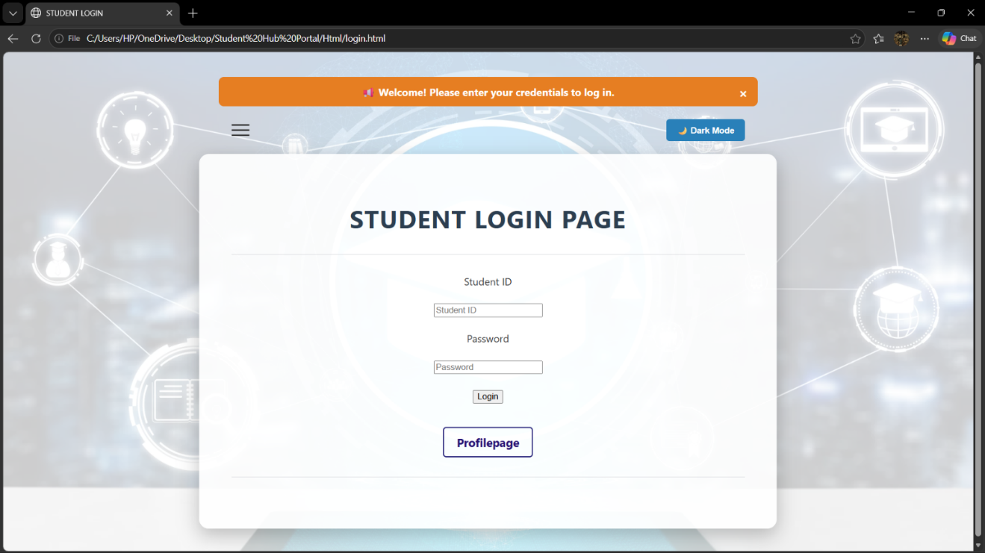

GitHub Repository Link:

https://github.com/RajMonani/Student-Portal-Hub

Challenges Faced:
While building the dark and light mode, the button was not working at all even though the code was correct. To fix this, I added a small notification popup to the button click, which somehow woke up the button and made it start working properly.

Learning Outcomes:
From this practical, I learned how to use JavaScript to switch between different screen themes (dark and light mode) and how to create interactive elements like dropdown menus.

Faculty Remarks:

